EXTRAS
- if u have a DateTime and want to get the differene between it and now (current time), you can use diff() method from DateTime, and if you want it to be easiky readable, use diffForHumans(). This method was from carbon libarary which laravel already has
- for email validation to also filter so that the input must have the right domain (@gmail.com not only @gmail), use email:dns validation rule
- MVC structures: every table in database has its own model, every controller has its own folder in views
- To manipulate ‘active’ class for navbar, you can do if statement checking the route using Request::is(routeName)
- when using @foreach directive, we will have access to $loop variable which have some handy methods https://laravel.com/docs/9.x/blade#the-loop-variable
- To check route list use php artisan route:list, to clear cache use route:clear as sometimes new route hasn’t been loaded because of old cache
*notes based on sandhika galih’s Laravel 8 tutorial
- after installing this and that, usually you need to start ``php artisan serve`` to launch the web. Now after you followed the valet method told on the video, you can simply launch em (without turning on artisan serve) by typing webFolderName.test e.g. rental-mobil.test
- controller folder is on app/Http/controllers
- model folder is on app/Models
- view folder is on resources/views
- web routing is on routes/web.php
- to put our static assets like css js images we put it on public folder, not in resources/css or /js cuz those are for bundling
- to put database info, default app htp, etc open .env file

- to show a view simply use view(viewName) e.g view(‘home’) where the name just consist name without its extension
- for now put blade between file name and extension e.g. home.blade.php, this is for Laravel templating

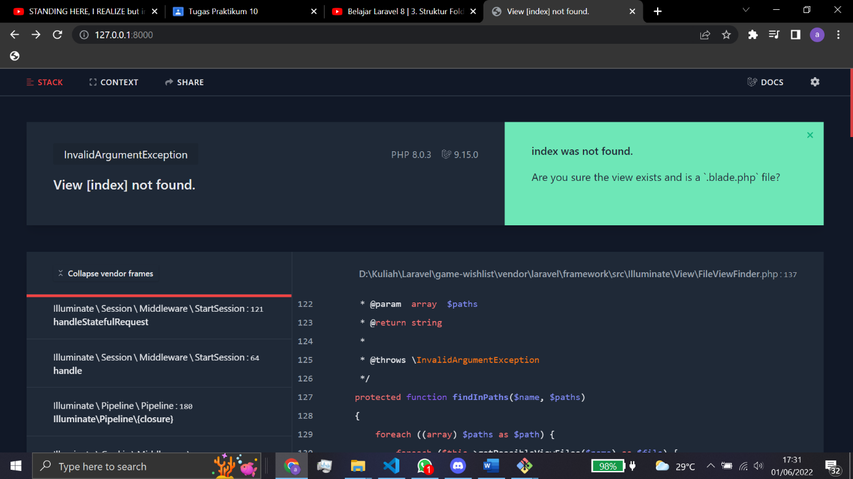
- ayy look at this cool error presentation from Laravel

- before its been told that any static assets went to public folder. When you in example referencing external css, you don’t need to href=”public/style.css” but href=”style.css” instead as public is automatically related to public folder
- to send data to view simply add an assoc array next to view name in view() method e.g
view(‘home’, [ “pageName” => “Home Page”, “user” => “WeDay”])
then use that data in the view basically call the variables as it will turn into variabel e.g. $pageName and $user

- templating engine is an engine to organize website’s appearance/presentation/view by a framework
- Laravel’s templating engine is called Blade and automatically installed
- Blade is a templating engine that runs in PHP, in fact all of it syntax then will be compiled into php. To use it simply use .blade.php extension
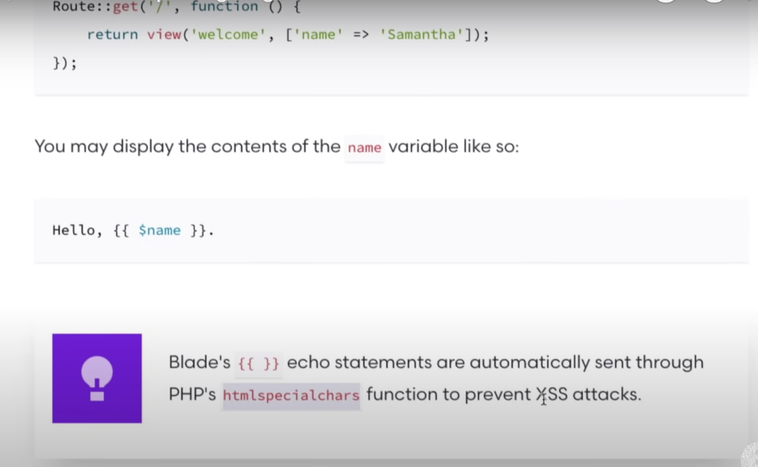
- Example of blade syntax
No need to use php echo

- in fact, you can still see the compiled blade version in storage/framework/views and u can see a jumbled php name. One of them will contains ur php view version where the blade syntax already compiled

- Blade has layouting system where u just need to use a template layout and only change needed information (because not 100% content is different every page, there must be a same thing every page)
- to do that first make a layout view, for better programming habbit u can make a layouts folder inside view folder. There, you put all the template layout THEN u mark the part where data will change using @yield(sectionName) e.g. @yield(‘content’). That part is called a section and will be filled with whats been put inside that section
- Now to use that layout to a view, you use @extends(layoutName) e.g. @extends(layouts.main) if u put the layout inside layouts folder (notice u can use either slash or dot so layouts/main works the same). Also, if the syntax is correct then it will automatically has an underscore where then u can ctrl+click to directly go to that layout (cool eh)
- Then, we will define what to put in the section in the view by wrap it inside a @section(sectionName) and @endsection. Notice that the section name must be the same

- we also make a partial which is a component that can we install and reinstall freely through a view, for better usage create partials folder. To use it simply use @include(partialName) e.g. @include(‘partials.navbar’)

- Blade’s {{}} is not limited just for displaying variable, just use it as usual like u can also use a ternary operator
- blade’s var_dump is @dd()
- for blade’s foreach simply use @foreach and @endforeach

- for a route to be able to capture parameter is called wildcard, wrap the parameter with {} then include that parameter in the callback function’s parameter to use it
e.g wildcard name is slug
Route::get('/list/{slug}', function ($slug) {

- laravel has Object Relational Mapper (ORM) called Eloquent, to organize models easier
- to make a model use command in editor terminal (If vscode use ctrl+` to open terminal) php artisan make:model modelName to make automatically make model or u can make it manually in the model folder
- model name should be singular and PascalCase
- to use a model we first need to declare it by using use keyword and its path e.g. use App\Models\ModelExample.php

- php related, to refer to a static method from the outside use ClassName::staticMethod() or for from the inside use static::staticMethod(), to refer a static property from inside instead of using $this->property use self::property

- in Laravel, there are an array wrapper called Collection, u can wrap any array as an collection simply by using collect() e.g. $arrayAsCollection = collect($array)

- Collection has a ton of handy methods, sneakpeak: https://laravel.com/docs/9.x/collections#available-methods
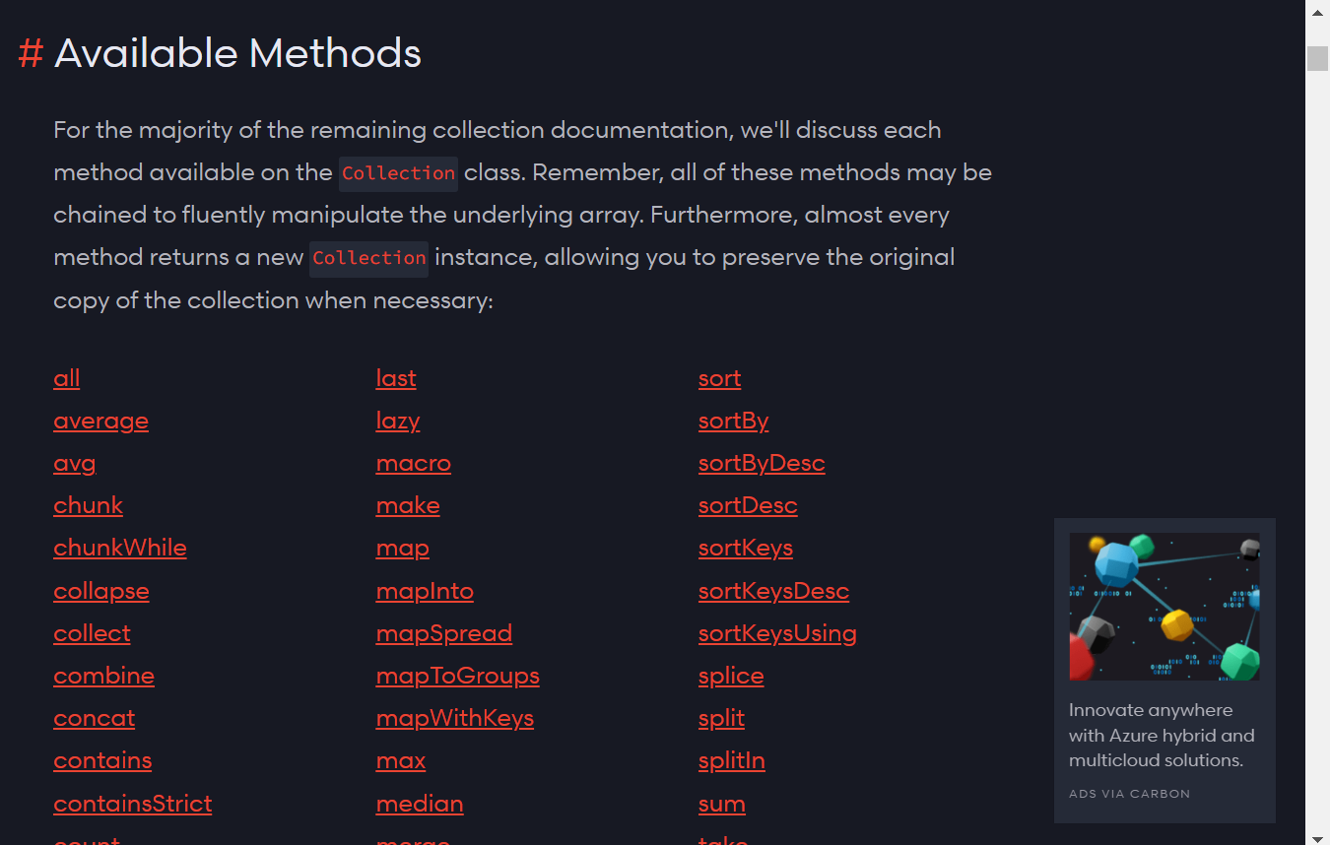

- to make a controller, use command php artisan make:controller controllerName –invokable or again u can manually create it
- controller naming convention is PascalCase, singular, and ended with Controller e.g. ProductController
- same as model, controller also needs to be referenced using use keyword e.g. use App\Http\Controllers\ExampleController.php
- To use controller’s function, change the currently-used closure/anonymous function at the route into [controllerName::class, methodName] e.g
Route::get('/', function () {}) before, by default is using closure
Route::get('/', [ProductController::class, ‘index’) after

- controllers method still act like closure, if the method needs a parameter it automatically use the one provided in router. E.g.
Route::get('/show/{slug}', [ProductController::class, ‘show’) where show method takes a $slug parameter, it will automatically assign the wildcard from the routes into the method’s argument FOR NOW IDK WHY

- to configure like db config, app config we do it in .env
- database usage in Laravel is using Migration, basically it’s a git version for database
- in Laravel we associate to database with Migration
- by using migration we can instead code the query inside the Laravel rather than in the DBMS
- by default Laravel prepared a dummy migration table on database/migrations. Every migration is implemented into a class and every migration class has up() and down() method. Up() method is called when we do php artisan migrate command and down() method is called when we do php artisan migrate:rollback.
- By doing php artisan migrate we will call all up methods in the migrations folder and vice versa
- when using migrations, we also have an additional tables called migrations, basically it’s a .git folder for database, don’t do anything to it
- to do both rollback first then migrate, we can use php artisan migrate:fresh

- up method contains a creation of a tabel, the template is
Schema::create('users', function (Blueprint $table) {
$table->id();
$table->string('name');
$table->string('email')->unique();
$table->timestamp('email_verified_at')->nullable();
$table->string('password');
$table->rememberToken();
$table->timestamps();
});

Just change the table name (users) and the schema as needed.
- to see which data type or methods we can use for table we can see through https://laravel.com/docs/9.x/migrations#available-column-types

- and also to manipulate database we use Eloquent as laravel’s ORM
- ORM basically an approach to make database usage more like in OOP, so table is treated as class, record is treated as object, and field is treated as property
- ORM will make every database table has its own model so table and model are in a pair. So if we make model by ourself then its violated ORM approach. The model should be generated the moment we make a table in Laravel
- for example, Laravel has prepared User.php model and its table user that already in migrations default file. Both of these are in pair and followed ORM approach
- on the generated-through-orm model we will have a $fillable property which tells which field that can we fill by ourselves, the rest of the field will be handled by laravel
- to switch terminal into Laravel CLI mode we can use php artisan tinker, we can test thing do things here instead of hardcoded in a file
- here by using the User model and user table prepared by Laravel, you can try to do the CRUD of database through coding
- make a variable and set is as a model handle by using $variable = new ModelName e.g. $user = new App\Models\User or $user = new User as long we put it in the right folder (the app\models folder) then it will autocomplete
- then by that handle we can use Eloquent methods i.e all() and find(), or we can create a new record through filling the property e.g. $user-> name = ‘test’, don’t forget to use save() method to save the inputted data and actually make the record

- NOW, to make a model AND our migration file we can use php artisan make:model -m modelName, this will also generate a migration create table file, there we can then code our table creation

- when making a table we NEED to also make published_at, created_at, and updated_at because this motherfucker Eloquent wanted to also fill that field. To make those use
$table->timestamp(‘published_at)->nullable();
$table->timestamps(); //this will create both created at and updated at

- when u create changes in model, u need to restart the tinker mode
- {{}} syntax also will be htmlspecialchars()-ed, to disable that use the {!! !!} version
- Eloquent’s create()
- migration only records database schema, if ur migrate:fresh then the data will be lost
- to assign every property and save() in one go u can use mass assignment using create(). But, the field need to be defined as fillable or guarded for the table to be able to execute mass assignment. You need to make a protected $fillable or protected $guarded that contains fillable field for $fillable or unfillable field for $guarded, choose one of them

- before, we use wildcard for parameter in the url like list/{slug}, now we ll use better method which is Route Model Binding, basically using a model representasion instead in the route.
- The way is still same but instead a random wildcard name, we better directly use the model name we wanted to bind e.g. binding Product model then we in our route we use /list/{product}
- The difference is, now on the callback (assuming now already make use of controller not default closure) we too will pass the parameter and it must be the exact name as on the parameter, and it is an object of the model, e.g.
Route /list/{product}
Controller [ProductController::class, ‘show’]
The method public function show(Product $product){ }
- The benefit of using route model binding is we directly using the model representative as the argument which means it also done the query. This is one step faster than we get the parameter, then in controller we do the finding query using model
- by using only the model name then we implistly find using the id, so
Product $product equal $product = Post::find()
- To use another property as parameter simply add the property after the model name and separated by colon e.g. {product:slug}

SKIPPED BUNCH OF VIDEOS

- we send post data as a form of Request object
- to validate simply use request method’s validate() e.g. $request->validate() where we then pass in an assoc array containing the rules for the field, u can make it directly or store it into variable first (then pass it into validate())
- Laravel is smart enough to cancel the submission of a form if the request is invalid
- You can check if any field is error by using @error(fieldname) @enderror in the form’s view. It will shows if that specific field’ validation failed. You can do the error feedback freely with that
- validation rules https://laravel.com/docs/9.x/validation#available-validation-rules
- to show the error message u can use $message inside that field’s @error
- after form submission to keep the old value you can use old(fieldName) method e.g. value={{ old(‘name’) }}

- to redirect user to other page u can use redirect()
(idk why I haven’t been using session but it works)
- to send a flash message to that redirected page u can combine it with with() e.g. redirect(‘/’)->with(‘success’, ‘data has been added’). It will then can be captured with session()->has(flashDataName) method. You can check that flash data presence using @if @endif directive

- in an EDIT section, you will have an input box initially having the edited item’s info. But then, you also want to keep the old value if the form submission fail using old(fieldName). So, the solution is simply add another argument that will be the initial data. If the old() field is null then laravel will use that argument. E.g. old(‘title’, $item->title)
- when editing an unique field it will be a little tricky. You cant just validate it cuz if the value still the same then it will cause error. So the solution is u need to validate them separately using condition. Only validate when the value changes
- to update use Model::where(‘id’, $modelObject->id)->update($validatedData)

- as table is presented as ORM, and ORM in Laravel uses Eloquent, then table relationship is also called Eloquent relationship
- to make a foreign key field in migration that uses id, use foreignId(fieldname)
- talking about table relationship then we are also talking about cardinality like 1-1 or one to one, 1-N or one to many, and M-N or many to many
- to represent those cardinality into eloquent, we must follow eloquent’s rules about cardinality. Eloquent needs u to define the cardinality and its inverse
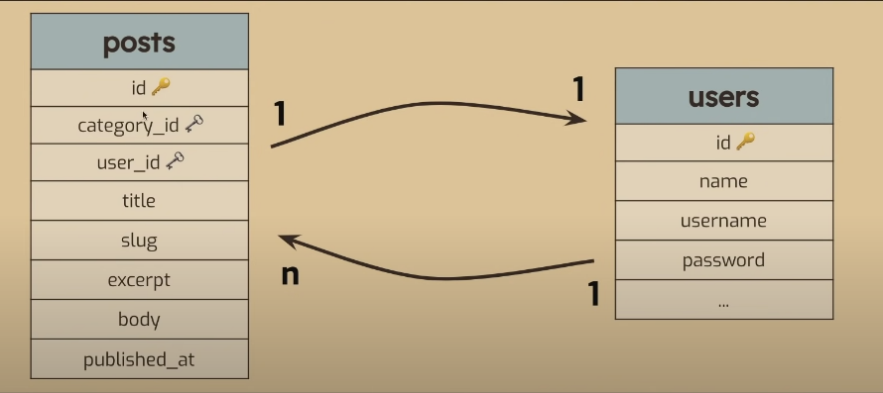
EXAMPLE: lets say we have these two tables

- to define the cardinality, first we need to choose which table’s PoV we are using so we can also define its inverse.
- here we will use ‘users’ table pov, user able to create many post, hence the 1-N for the cardinality. Meanwhile for the inverse, a post can only be made by one user, hence the 1-1 for the inverse cardinality
- using ‘users’ table pov, the cardinality will be “an user hasMany posts” and the inverse cardinality will be “post belongsTo an user”
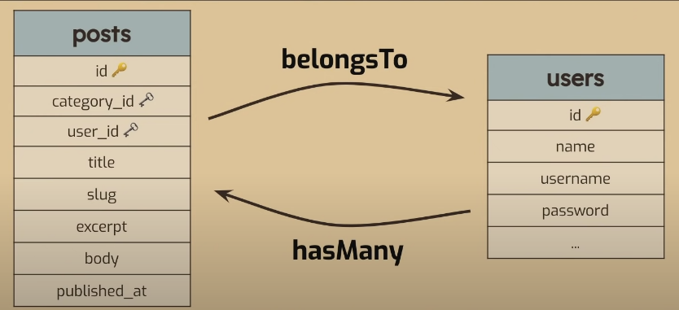

- Now lets switch pov. Now we are using ‘posts’ pov. Then, the cardinality would be “a post will only hasOne user (who made it)” and the inverse cardinality will be “an user (as a post maker) belongsToMany posts”
- Now u can see that a (main) cardinality starts with ‘has-‘ while inverse cardinality starts with ‘belongsTo-’
- Both are logically valid, the syntax is based on which pov u are using. But still, in Laravel syntax there are also extra rules.
- in 1-1 cardinalty, you may use hasOne and belongsTo
- in 1-N cardinality, you may use hasOne, hasMany, and belongsTo
- in M-N cardinality, you may use belongsToMany (this is the difference between belongsToMany and hasMany)
- Now, to choose PoV, you need to chose the table who doesnt carry the foreign key, so then its inverse cardinality would be the table who has the foreign key and then use “belongsTo-“. So on above case, the right pov to choose is ‘users’ table as the foreign key is one the other table – ‘posts’
- key to choose pov: the table who has its foreign key must become ‘belongsTo-‘ syntax
- those are for 1-n and 1-1 relationship (still dk for m-n)
- as in ORM, now you also need to connect both tables in their models. Now you may create a method that named precisely like its table pair (with using the right singular/plural term) so when you call it, its like calling property (but now actually in method form), then you returning the method using above Laravel syntax while passing the actual model’s class. E.g.
(using users and posts table above)
In Post model
public function user(){
return $this->belongsTo(User::class);
}
In User model
public function posts(){
return $this->hasMany(Post::class);
}
- notice that at the belongsTo, the method use singular form while hasMany uses plural form, its because the belongsTo actually will return one instance where hasMany is expected to return many instances
- But still, when u call in the code, you don’t need to use () e.g. $post->user not $post->user()
NOTE: you really need to match the method name because they use it to match it with the id. If not then u need to explicitly tell it u are using alias, e.g. author(){ . . . return . . . User::class, ‘user_id’);
DATABASE SEEDER AND FACTORY
- in development process, it is very likely that we make changes to our database schema. This is resulting that we need to migrate:fresh to apply those change. And so, then our previous records will also be lost and we need to insert them again. This is obviously cumbersome.
- So, Laravel has a database seeding feature, means that we can plant seeds or make some dummy record to be inserted to database and then we can collect the fruit or populate aforementioned dummy record to the database. So, every time we migrate:fresh, we only need to seed it so the tables will be back to be populated with records again, saving our time to manually inserting them again.
- To do that, we will put all the insertion statement into run() method of our DatabaseSeeder.php file that can be found in database\seeders\ e.g.
public function run()
{
User::create([
'name' => 'andy',
'password' => '12345'
]);

User::create([
'name' => 'sarah',
'password' => '54321'
]);
}
- above, will populate two records on User table
- don’t forget to reference the model namespace in this file to actually use their create() method
- now, to run those seeding statement you can use php artisan db:seed, it basically will run this run() method inside DatabaseSeeder.php
- beware of doing above command twice as it may resulting error because basically you run the insert statement twice which might violates field uniqueness (e.g. name must be unique but you insert two user with same name)
- for a shortcut, you can also use php artisan migrate:fresh --seed to do migrate:fresh and db:seed in one command

- now we already using seeder, but its basically run an insertion script which we still type manually. If we want to seed 50 records that means we must also do insertion for 50 records, still cumbersome
- so, Laravel has a factory feature, basically generating a lot of dummy record based on the definition we already make for that table.
- Factory is a part of model so the naming convention would be ModelFactory e.g. ProductFactory. To make one do php artisan make:factory factoryName.
- Actually the factory has no reference to its model, but in model you can use use hasFactory (its there by default if u use make:model command). So, you need to follow the naming convention or the model wouldn’t be able to find its factory
- On the factory file, all you want to edit is on the definition() method, at the array in the return statement. There, you will make the rules for the generation of dummy records. For example, this is the factory made by Laravel by default, the UserFactory
public function definition()
{
return [
'name' => $this->faker->name(),
'email' => $this->faker->unique()->safeEmail(),
'email_verified_at' => now(),
'password' => '$2y$10$92IXUNpkjO0rOQ5byMi.Ye4oKoEa3Ro9llC/.og/at2.uheWG/igi', // password
'remember_token' => Str::random(10),
];
}

- we need to define every field’s factory rules.
- as you can see, we are using a faker, that is a library for making dummy data. Laravel has it integrated so you don’t need to install the library. Its website: https://fakerphp.github.io/
- there you can see which formatter you can use for faker
- You also able to have a localized data that able to be localized like names, by default it is using en_US localization so it will generate American name
- There are Indonesia localization, the key is id_ID. To change Laravel’s faker localization, go to config/app.php and search (ctrl F) for Faker locale. You can change the statement to ‘faker_locale’ => ‘id_ID’
- keep in mind they only use localized data only if they have em,. If not then it will become english
- also u can see that if you want to generate a dummy but it needs to be unique, you put the unique() before the formatter e.g. $this->faker->uniquer()->email()
- BUT, not all field able to be generated by factory, in example is the foreign keys.. so you still need to make the other way to fill those in the factory’s definition, either using mt_rand() to generate random number, or something

- now, to use the factory, simply use modelName::factory(numberToBeGenerated)->create() e.g. Product::factory(10)->create() to generate 10 dummy records
- for completeness now when making model you can also make its factory by using php artisan make:model -f modelName or even, also make both migration and factories by using -mf instead

N+1 PROBLEM
- n+1 problem is a problem where we unneficiently making database query when we are looping. This problem is negligible when the data still small, but if its already hundreds or thousands, it will backslash our app performance
- The problem happens when we are doing a Lazy Loading, a term where we only do the query when the data actually needed, resulting a dozen of queries only for a small data
- this problem happens when we have a table has relationship to another table, when we are using hasMany, belongsTo, etc, we r literally doing a query for that table pair
- for example, let Post table has a belongsTo cardinality towards User table. When we are displaying all the post data, let say it has 5 post, when its in Lazy Loading, we actually making a 6 query which is
1. query to get all post records, e.g. Post::all()
2. query to get User for first post, effect of belongsTo
3. query to get User for second post, effect of belongsTo
4. query to get User for third post, effect of belongsTo
5. query to get User for fourth post, effect of belongsTo
6. query to get User for fifth post, effect of belongsTo
- the solution of this is a Eager Loading, means that we will load all data even it hasn’t been used yet. For comparsion, the query would look like these
1. query to get all post records, e.g. Post::all()
2. query to get all User that will be used for all the posts, e.g. User::where(‘id’, [1,2,4,6]) this process will be automated
- as you can see, the difference is 6 vs 2 where 6 is because of N+1 where N is total number of posts. That’s only when the data is small. Let say now our posts is 100, then the comparison would be 101 vs 2 – that’s quite a difference!
- Now lets talk for the technical solution. To make a query become Eager Loading, we will be using with() to specify that we also be querying a table with another table that relevance to the data. the table added inside with() needs to be undercase and follows its actual table’s model, e.g. for above example case for User and Post, we use Post::with(‘user’)->get() , note that we cant use all() it’s a static method and we now using with() static method, so we now follows it with get(), literally the same
- by doing above example, it will create 2 query like mentioned above on Eager Loading

- another thing is, there are cases when we actually needs to wait a data to be loaded then we do the eager loading, this is called LazyEagerLoading. This case happens in example on the Route Model Binding (also because we cant use static methods here)
- example is, lets now say that a Post also have a Category, same cardinality like Post and User where Post belongsTo Category. Now lets say we want to show all post based on a category, so we make a route with route model binding, binding the Category model where it has posts() method that basically return hasMany(Post::class) (read back to cardinalities if u r confused). The code will look like this (assuming we do it directly with closure not with a controller)

Route::get('/category/{category}', function(Category $category){
return view('category', [
'name' => $category->name,
'posts' => $category->posts
]);
})

- as you can see, then we will back to doing a LazyLoading when we showing all the posts, because then all post will also refer to its user and category
- now, to make it into LazyEagerLoading, basically now we use load() method e.g. $category->posts->load(‘category’, ‘user’). This then will make the posts doing the EagerLoading
- so that’s it, its called LazyEagerLoading because first you do the LazyLoading, waiting for which category is being used, then we do EagerLoading for all the posts that category has
- For complete guide watch https://www.youtube.com/watch?v=q8FmWY5y0qI&list=PLFIM0718LjIWiihbBIq-SWPU6b6x21Q_2&index=11 , there also we install something to actually test how many queries we did, using Clockwork

UI part of video, skip skip watching
- previously for eager loading we use with() method on the controller. If you want to always eager load those tables everytime using that model, you can instead make a protected $with holding array of will-be-loaded tables name e.g. protected $with = [‘caterogory’, ‘user’]. Now u don’t need to use Model::with()
- if the url contains get’s form variable, you can capture it with request(varNam) instead of using $_GET var. Looks more readable and human

- to make a pagination, simply use pagination(numberOfItemPerPage) method at the end of query instead of using get() e.g. Product::latest()->pagination(10). It will also automatically create a get variable called page that takes care of the paging e.g. items?page=2
- To create the previous and next button, simply at the view, on that query’s variable, use links() at the end and echo them e.g $products->links(). BUT, as laravel uses Tailwind as its default css framework, the result may be bad If u are not using tailwind.
- To make pagination uses bootstrap, go to app\Providers\AppServiceProvide.php and on boot() method add Paginator::useBootstrap(). To use that paginator class simply include it by using use Illuminate\Pagination\Paginator
- if you want to style the links furthermore, do it on ur own
- Now, if you also using other get variable, then the pagination’s page variable will override everything. To solve this, basically add withQueryString() after paginate() method. Now other get variable still persist while using pagination

- we can both have a route with the same url but different method e.g. get(‘/product) and post(‘/product’) as both will be taken care of separately
- when using post method, we need to add a @csrf inside the form, as Laravel is preventing CSRF or Cross Site Request Forgery, basically a request done from other site with goal of doing harm to our website. If u don’t use @csrf, the page will be shown as err 419 | Page expired.
- If u already add the @csrf method but still page expired, try to refresh cookies
- post request also can be referenced using request() method. To show all of it use request()->all()
- before we use request() for reference to form submissions variable. We can instead make it into Laravel’s variable by adding into that method’s parameter a Request $request (var name mustn’t be same)

- Laravel has an authentication service to do auth easier. There are a starter kit like Laravel Breeze that already handled all general auth like login, logout, register, forgot password, email verif, etc. But at this course we’ll do it manually
- The auth service we’ll be using is called Auth, to use it include use Illuminate\Support\Facades\Auth. Documentation: https://laravel.com/docs/7.x/authentication#authenticating-users
- Auth has some handy method. One of it is attempt(validetedRequest). After we validate the login credentials, we then check if the credential is actually exist using this method as a condition. Also, if the method returns true then the session will be marked as authenticated. You can then redirect to other route after the attempt is success, e.g.
public function authenticate(Request $request)
{
$rules = [
'email' => 'required|email:dns',
'password' => 'required'
];

$validatedCredential = $request->validate($rules);
if(Auth::attempt($validatedCredential)){
$request->session()->regenerate();
return redirect('/dashboard');
}

return back()->with('login_fail', 'Login failed!');
}

- we do session()->regenerate() to prefent Session Fixing attack
- to simply redirect back to which the post form submission’s url from, simply use back() method
- keep in mind that if the validation is wrong then it will automatically back to the form page, like usual
- Auth::attempt() will check the password hashed, so if ur password in db is not hashed it wont work
- Now, you may realize that Auth able to check the credential automatically even we don’t tell it which model used for storing credentials a.k.a users. This is because the service Auth using the default model for checking which is User model. You can see it in app\config\auth.php at the providers part. If you use another model for credential then simply change the model’s value OR if you happen to not using Eloquent, then you can read the commented code below them

- to manage website when user is authenticated or not, we can use Laravel’s middleware
- Middleware is a mechanism to help us inspecting and filtering http request of our website. There are lot of middleware Laravel uses, in fact we implisitly already using middlewares until now, managed by default by Laravel.
- as its name, middleware works between the routing and the callback function. For example there will be a Route::get(‘/dashboard’), then middleware taking action, after that if passed then continued to the callback function, either a closure or using controller
- To see which middlewares we already using until now, we can go to the Global Middleware on app\Http\Kernel.php. All of the middleware declared here means we can now use it (and for global as the name says)
- For Authenticating mechanism we will use the auth and guest middleware (located in $routeMiddleware if u wanna see). Auth means user that has been authenticated and guest is vice versa

- Now implementing the guest middleware, we want our ‘/login’ controller route can only be accessed by user that marked as guest, so we then do Route::get(‘/login’, aCallbackFunction)->middleware(‘guest’);
- If u are in auth state but insist to access that /login url, you will be redirected to HOME route which is ‘/home’ url as default. If you want to change it go to app\Providers\RouteServiceProvider.php and change the HOME const to your liking
- If you want a specific frontend to show when in guest or auth state e.g. Login button in navbar only shown when in guest state, you can use blade directive @middlewareName and close it with @endMiddlewareName. That basically a condition that only true when you are in that middleware state. E.g
@guest
// show frontend when in guest state
@endguest
- You can also use @else inside it

- above is for guest middleware, now for auth middleware, is more or less the same. But, when a user insist to access when its not in auth state, by default it will be redirected to namedRoute called login
- as been said above, we can make a route to have a name, called namedRoute, simply use name(routeName) method after the route statement, if there are middleware then it is placed before middleware e.g. Route::get(‘/login’, someCallback)->name(‘login’) . Now, name a route as login to make it as redirect route for auth middleware
- we able to know about namedRoute login from app\Http\Middleware\Authenticate.php . There on redirectTo() method u can see the return route(‘login’)
- Laravel holds the user credential when in auth state, to access them, you can use auth()->user()

- for logout, simply use Auth::logout() statement. After that, other method that can be called to make our website more secure is $request->session->invalidate() to invalidate the session, $request->session()->regenerateToken() to regenerate csrf token(??), and then u can redirect

- Usually every model we make is for a resource, which is how Laravel says when a model is used for its CRUD. So, Laravel made a controller template so that we can easily manage our CRUD’s controller, so no more manually make create routes, read routes, update routes, and delete routes.
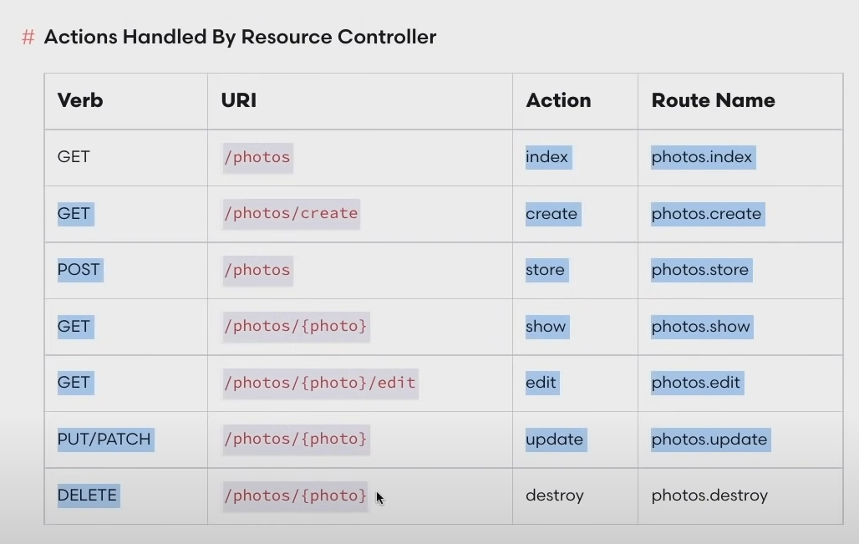
- The template is called Resource Controller, packed with all method we need for CRUD

- to make resource controller, use php artisan make:controller controllerName --resource or If you also want the controller to have a route model binding you can do php artisan make:controller controllerName --model=modelName --resource e.g. php artisan make:controller ProductController --model=Product --resource
- now to use that route controller, we use Route::resource() , using resource instead of get or post. Then, the route you put there will be the index also the root route for other method e.g. Route::resource(‘/dashboard/product’) . . . will then create ‘/dashboard/product/create’, ‘/dashboard/product/{product}’, etc
- but by using resource, out wildcard and route model binding is locked to refer to id. To solve that, theres another way thich is overriding the default column searched. By default is id, to change it make getRouteKeyName() method in its model and return column name’s string u wished to use
- as using resource controller, as mentioned above we use Route::resource(), defining the base url, AND THEN passing the controller in normal form NOT IN array form e.g. ProductController::class not [ProductController::class]
- note that route model binding follows the wildcard name, while when using resource route, the wildcard then will follow its root route, pay attention to the usage of that name as it also will be used as the variable name for that model
- as you notice there are VERB column, it is for the method typ, the method would work only if the method type is correct. As you know there are only POST and GET method in form, to add more, simply use @method(methodName) , its called method hijacking. Don’t forget its case sensitive. E.g @method(‘DELETE’)
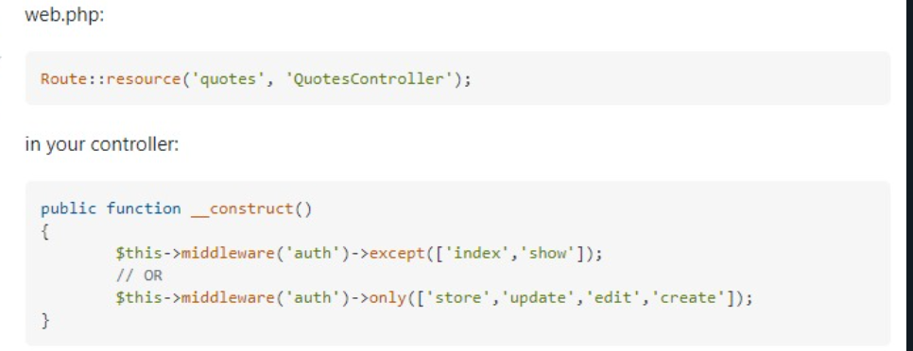
- also, organizing middleware in resource route has slightly different way:
Use except to exclude some methods or only to include only some methods

